Ryan Woodward
100201137
CPSC 1050
Feb 19, 2015

CPSC 1050: Introduction to Computer Science

Lab on Abstract Data Types, Algorithms

Complete this template and submit with D2L.

Applet: http://faculty.mc3.edu/pvetere/Applets/

LAB 9A

Exercise 1
url: http://faculty.mc3.edu/pvetere/Applets/APPLETS/STACKQUEUE/applet_frame.htm

2. [1 mark]
Steps
- Click clear (button)
- Click Show Stack (button)
- Push the three names "Abe," "Betty," and "Charles" onto the stack
  - One name at a time
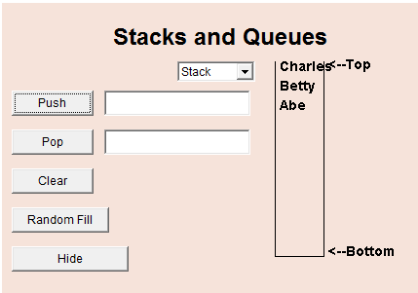

Question: When you pop the stack 3 times, what do you see in the textfield next to "Pop"?

- In the textfield next to “Pop” after popping the stack 3 times we see the name Abe

Exercise 2
url: http://faculty.mc3.edu/pvetere/Applets/APPLETS/STACKQUEUE/applet_frame.htm

4. [1 mark]
Steps
- Select "mystery" from the pull-down menu.
- Click Show Stack (button)
- Click Random Fill (button)
- Click Remove (button), Observe which number gets removed first
  - LIFO = Last in , First out (Stack)
  - FIFO = First in, First out (Queues)
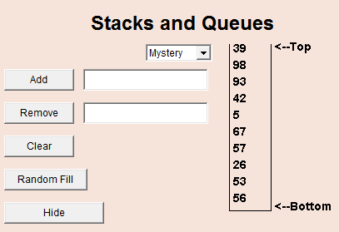
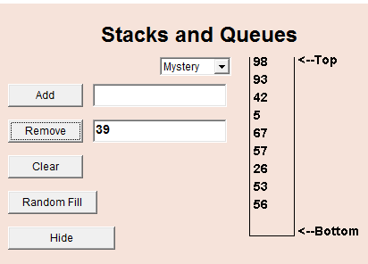
Question: is the mystery object a Stack or Queue?

- This mystery object is a Queue, this is because it follows the FIFO principle of first in first out when numbers get added. Adding a number to the queue and then pushing the remove button afterwards further tested this. The number that was immediately added was not removed

Exercise 3
url: http://faculty.mc3.edu/pvetere/Applets/APPLETS/TREES/applet_frame.htm

3. [1 mark]
Steps
- Select "Insert alphabetically" from the pull-down menu.
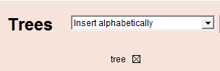
- Then type the following flowers into the textfield, pressing return after each one.
Sample output when Lily is entered
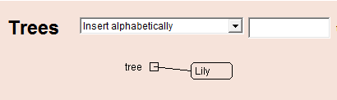
Lily
Rose
Daffodil
Tulip
Petunia
- Take a screenshot.
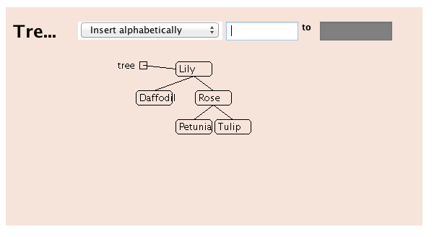
- Now perform a manual search for "Poppy." Put a check mark next to each node that you visit during your search. You can confirm your ideas by selecting "Find" from the pull- down and asking the applet to search for "Poppy."
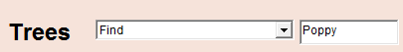

- The search hit the nodes “Lily” -> “Rose” -> “Petunia” when searching for poppy, before being unable to find it.

Exercise 4
url: http://faculty.mc3.edu/pvetere/Applets/APPLETS/TREES/applet_frame.htm

4. [1 mark]
a. Type in the following flower names in the given order. (If you don't want to type a lot, just use the first letter of each name.) Take a screenshot when done.
Aster
Bluebell
Coreopsis
Daisy
Echinacea
Fern
Gladiolus

What does your tree look like? Describe it in words below.
- My tree is simply one long tree that continues to branch onto the next flower. Each flower has only one child, which is the next flower in alphabetical order

7. [1 mark]
a. Clear the tree and insert the flowers in some other order so that the tree is balanced and complete.
Remember that this means that all nodes except the leaf nodes have exactly two children. After you are successful, take a screen shot. Also write down the exact order that you used to get it to look this way.
Leaf node is a node without any children

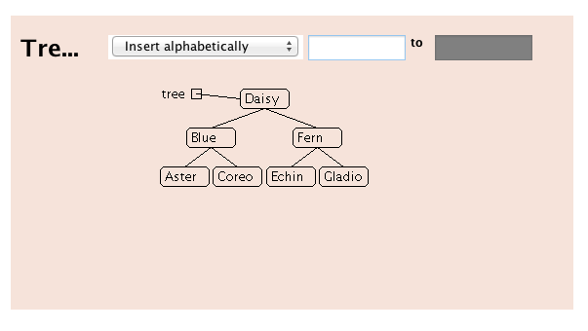
- Order of Insertion
  - Daisy
  - Blue
  - Fern
  - Aster
  - Coreo
  - Echin
  - Gladio

Exercise 5
url: http://faculty.mc3.edu/pvetere/Applets/APPLETS/TREES/applet_frame.htm

3. [1 mark]
a. Choose "Example 2."
b. Select "Insert Alphabetically." Then type "Mark" in the textfield and press Return.


Take a screenshot.
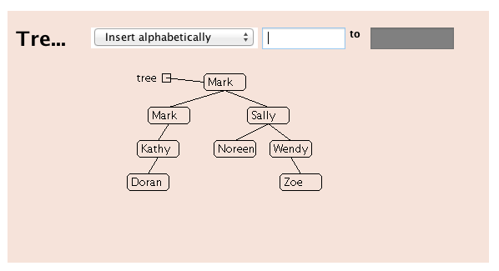

4. [2 marks]
Insert another name that is already in the tree. What does this applet do when you ask it to enter a name that is already there?
Example: Select "Insert Alphabetically." Then type "Sally" in the textfield and press Return.

- When Sally was inserted into the tree, it simply reacted the same as Mark, it created a child node of the same name attached to the original Sally node, and kept the Noreen node attached.

5. [2 marks]
Does find still work? Try to find a name, like “Mark,” that is represented by two nodes. What happens? Describe.

- When searching for a name, it stops on the first name that matches the search field and indicates that is the name that it has found. It totally ignores the children nodes that contain the same names

